1. Write a program to find the square, cube of the given decimal number

Sample Input:

Given Number: 0.6

Sample Output:

Square Number: 0.36

Cube Number:0.216

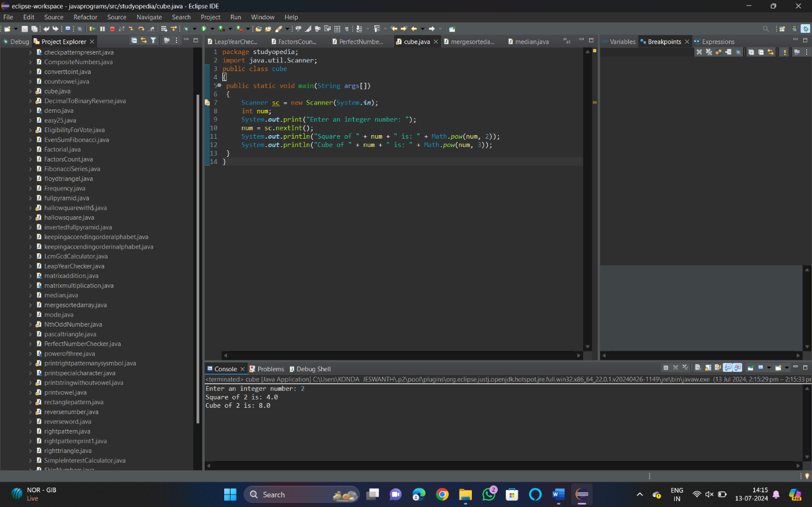

1. Find the nth odd number after n odd number

Sample Input: N : 7

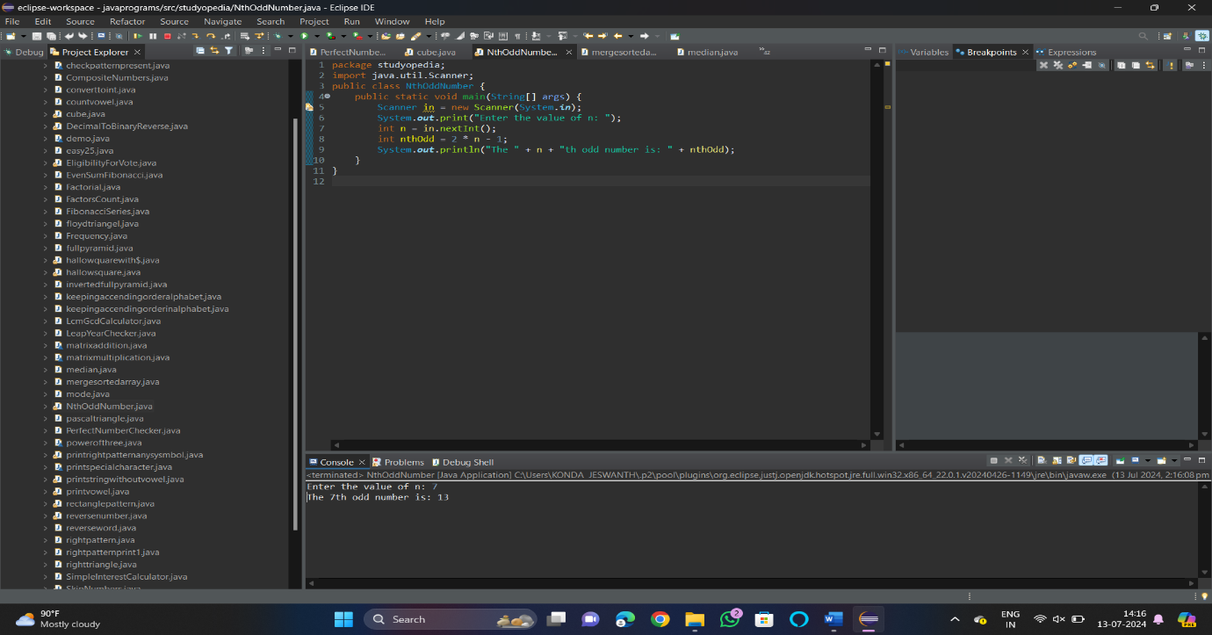

1. Program to find the frequency of each element in the array.

Sample Input & Output:

{1, 2, 8, 3, 2, 2, 2, 5, 1}

**Pseudo**:

Element | Frequency

--------------------------

1 | 2

2 | 4

8 | 1

3 | 1

4 | 1

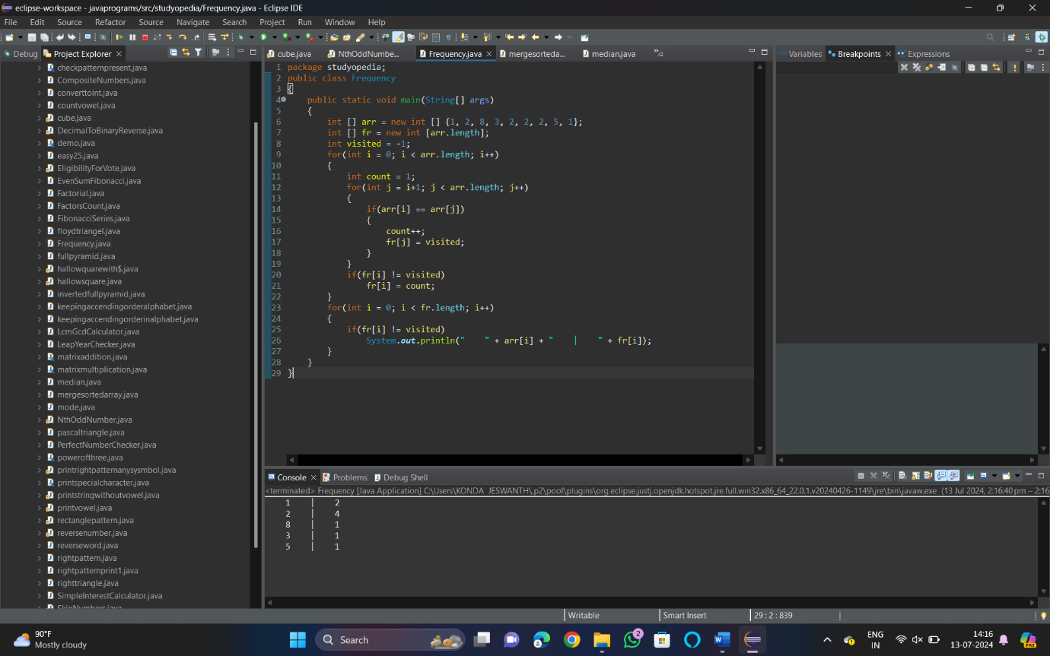

1. Program to find whether the given number is Armstrong number or not

Sample Input:

Enter number: 153

Sample Output:

Given number is Armstrong number

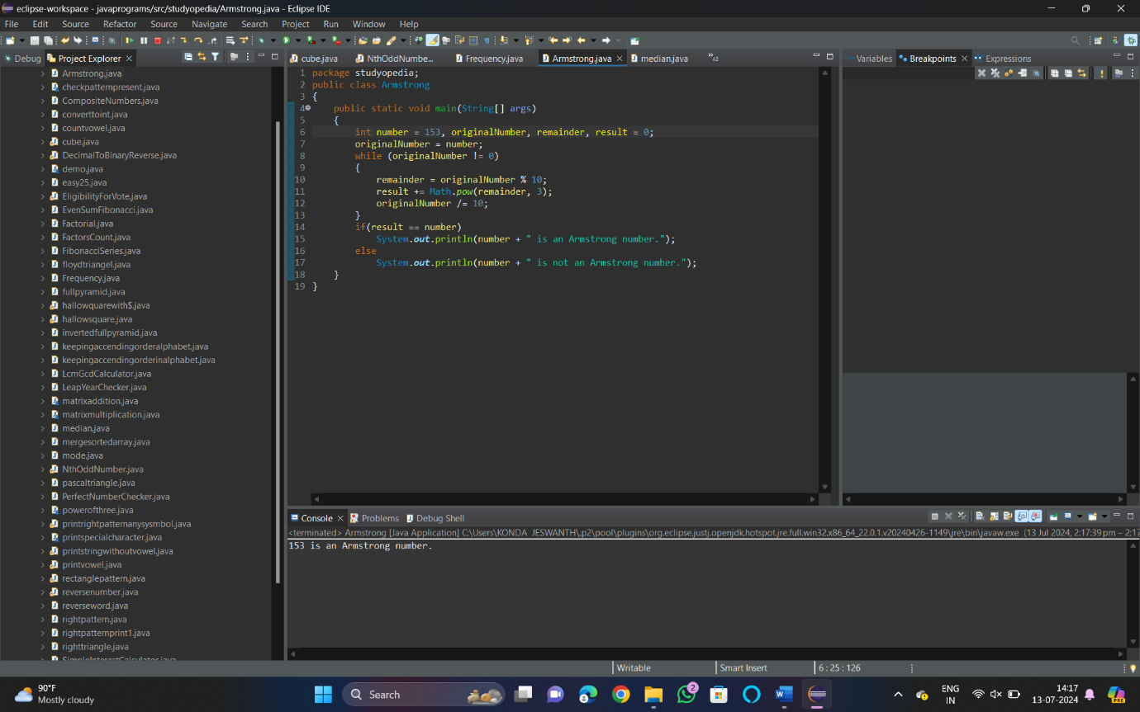

1. Write a program to find the sum of digits of N digit number (sum should be single digit)

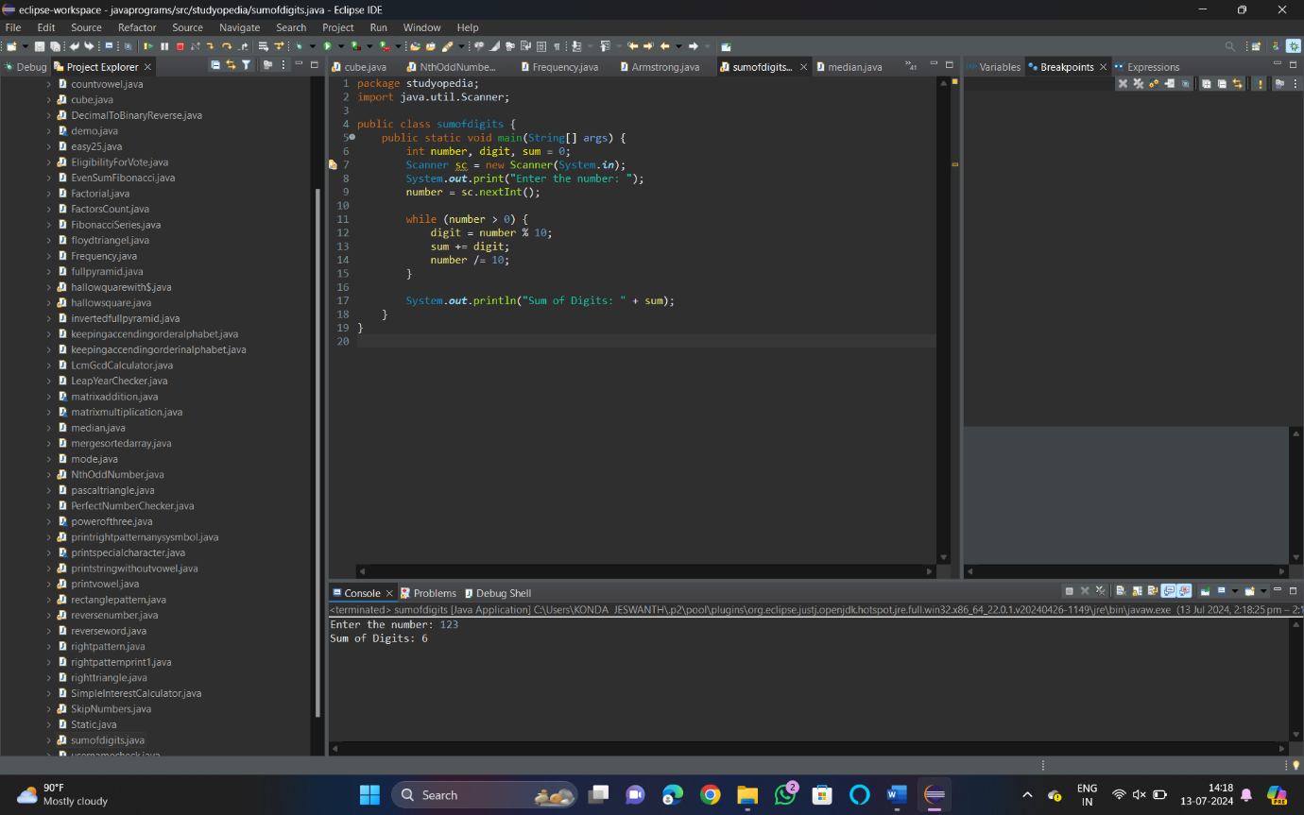

1. Write a program to find the square root of a perfect square number(print both the positive and negative values)

Sample Input:

Enter the number: 6561

Sample Output:

Square Root: 81, -81

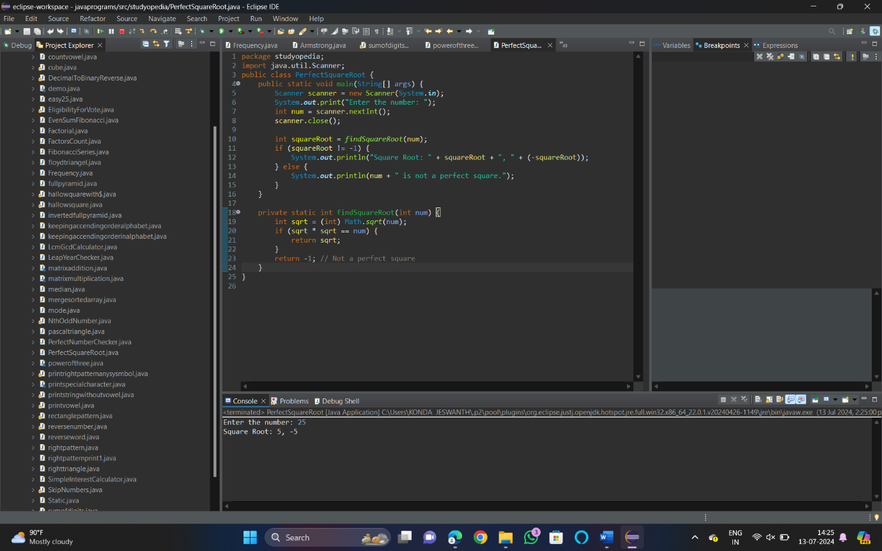

1. Write a program to given an integer n, return true if it is a power of three. Otherwise, return false.

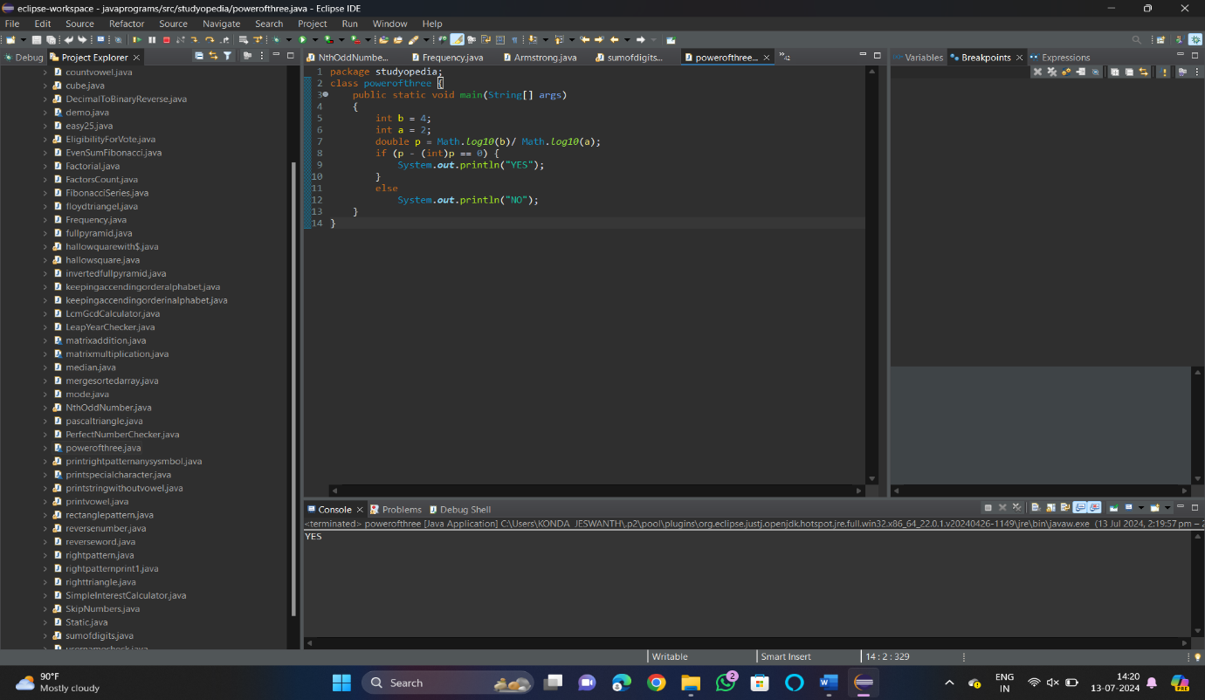

1. Write a program to given a string paragraph and a string array of the banned words banned, return the most frequent word that is not banned. It is guaranteed there is at least one word that is not banned, and that the answer is unique.

Input Paragraph=”Ram hit a ball, the hit ball flew far after it was hit”,

Banned = [hit]

Output=”Ball”

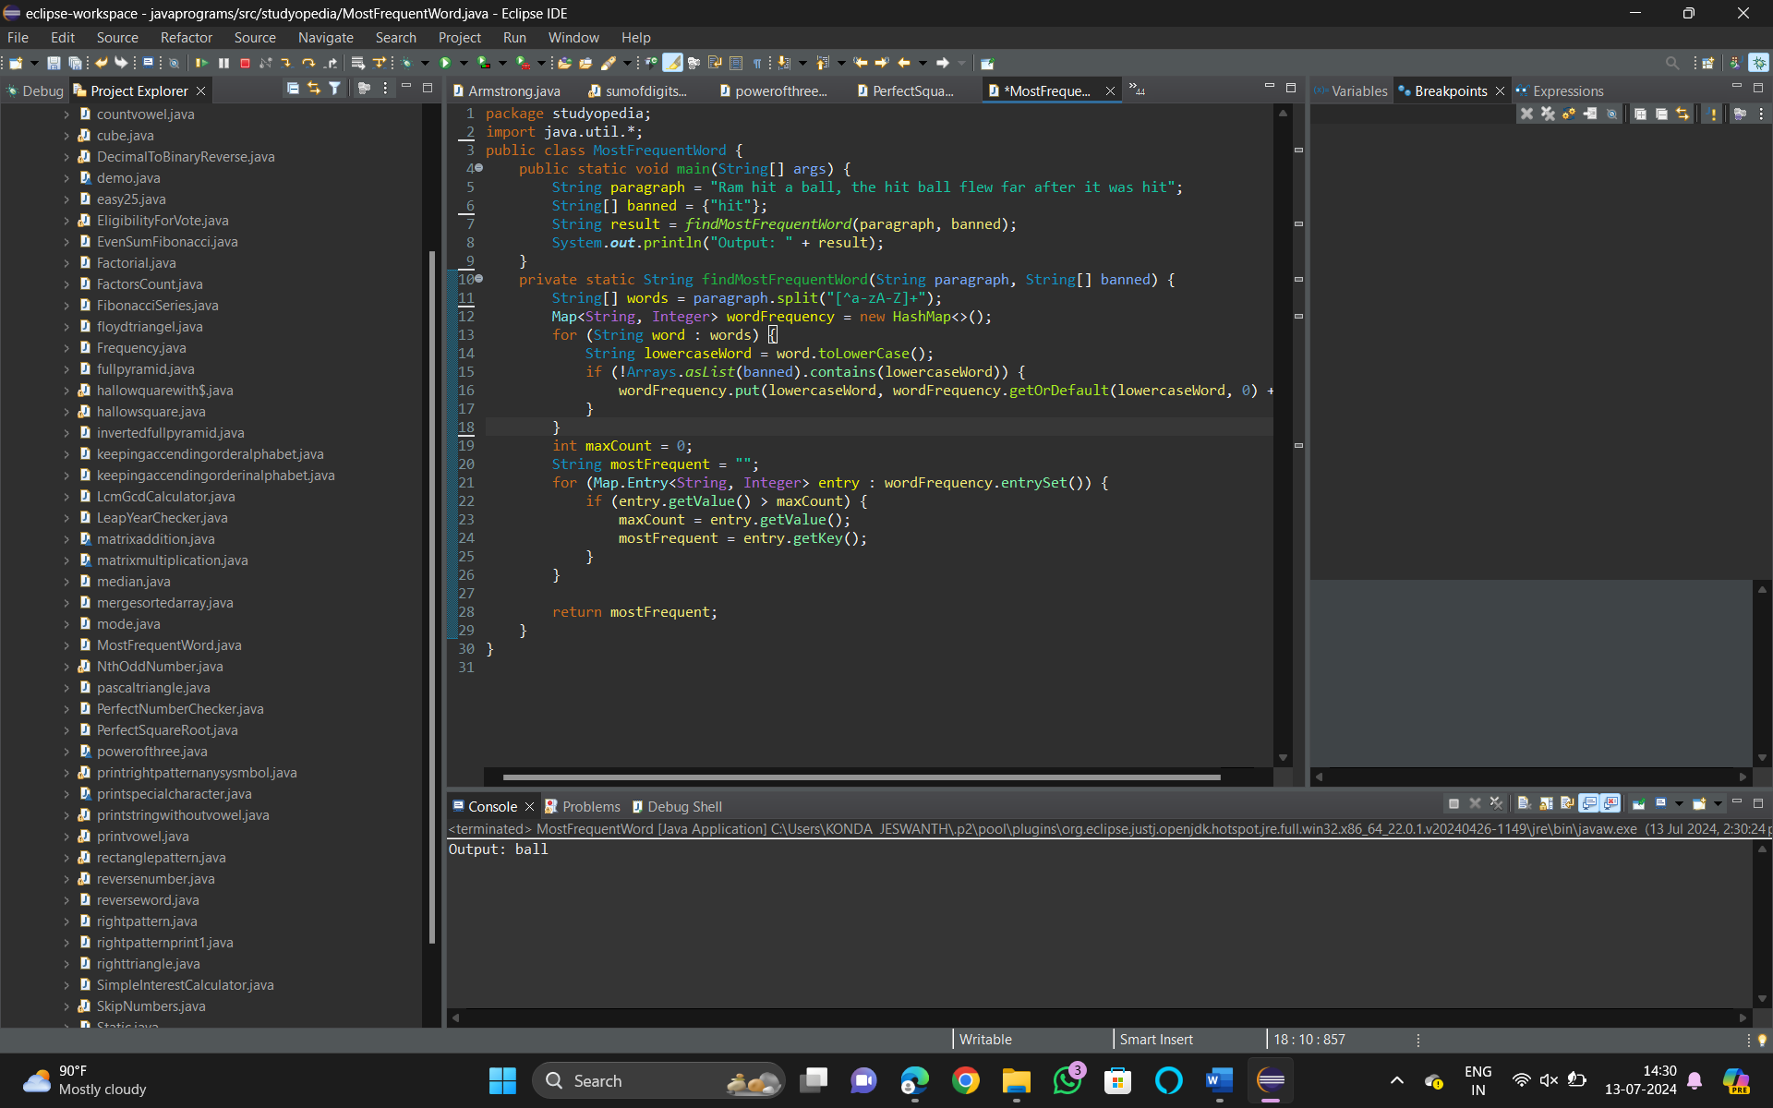

1. Write a program to given a fixed-length integer array arr, duplicate each occurrence of zero, shifting the remaining elements to the right.

Input: arr = [1, 0, 2, 3, 0, 4, 5, 0]

Output: [1, 0, 0, 2, 3, 0, 0, 4]

Explanation: After calling your function, the input array is modified to [1, 0, 0, 2, 3, 0, 0]

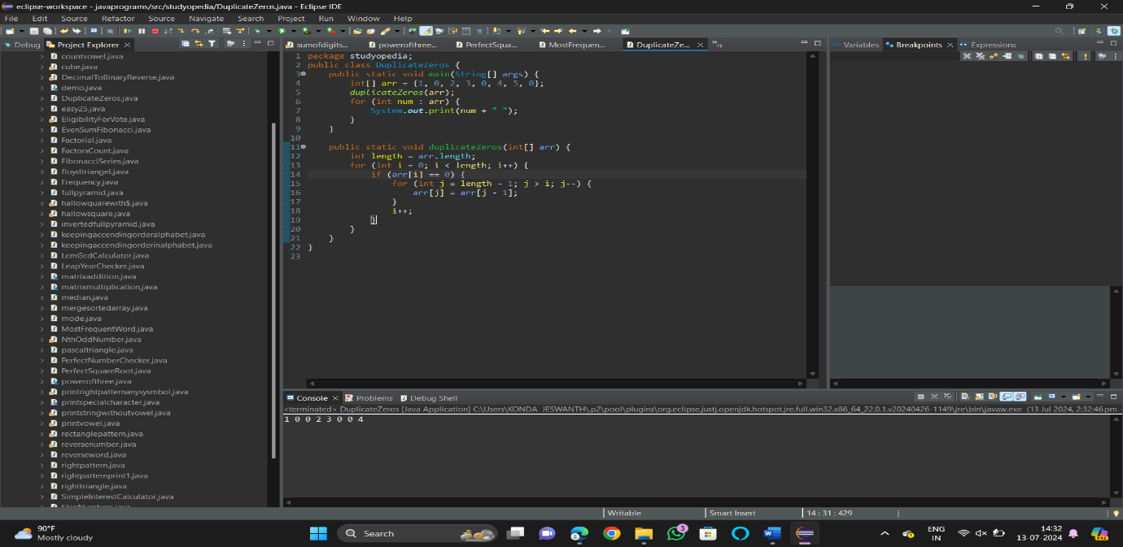

1. Write a program to given an array nums containing n distinct numbers in the range [0, n], return the only number in the range that is missing from the array.

Input nums = [3, 0, 1]

Output: 2

Explanation: n = 3 since there are 3 numbers, so all numbers are in the range [0, 3]. 2 is the missing number in the range since it does not appear in nums.

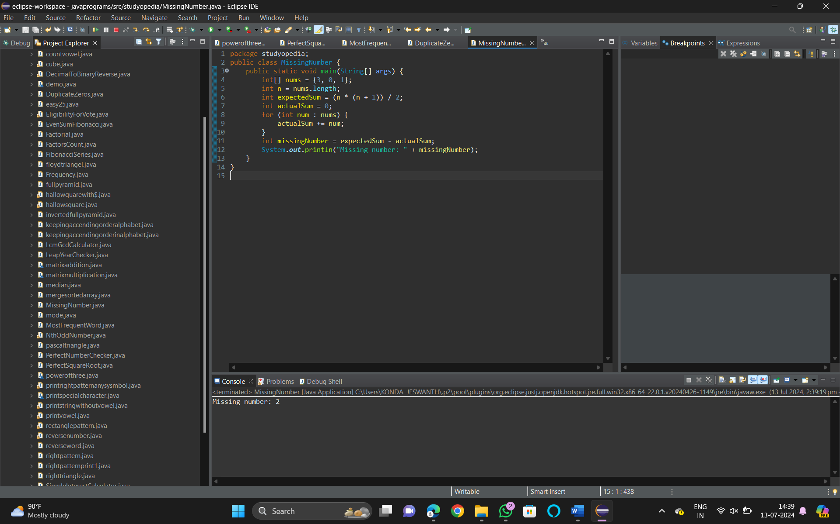

1. Write a program to given an integer array nums, find the subarray with the largest sum, and return its sum.